**Windows 11 file sharing troubleshooting methods**

1. **W + Edit group policy > Administrative Templates>Network>Lanman Workstation>Enable insecure guest logons>Enable>Apply>Save**
2. **W+ Power Shell>Run as administrator > paste the command >**

**Set-SmbClientConfiguration -RequireSecuritySignature $false**

1. **Click enter > write Y > Press enter > write exit**
2. **Win + R**
3. **\\192.168.10.39** **> enter**
4. 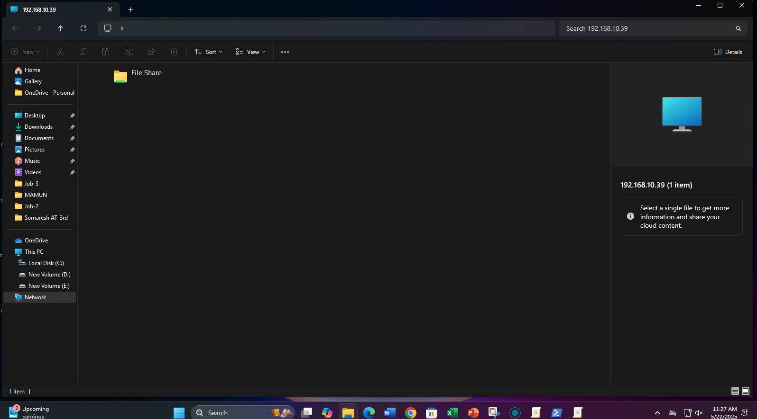**output should be look like this-**